ITEM PF13
OXFORDSHIRE PENSION FUND
REPORT AND ACCOUNTS 2003-04

CONTENTS
Page

Foreword by the Head of Finance 2

Members, Managers and Advisers 3

How the Scheme Operates 4

Membership 5

Participating Employers and their Contribution Rates 6

Investment Objectives 7

Investment Review 9

Investment Benchmark and Performance 14

Pension Fund Accounts 2003-04 15

Top Ten Holdings as at 31 March 2004 24

Auditor’s Report 25

Actuarial Statement 26

Summary of Benefits 27

Statement of Investment Principles 29

Communication 34

Useful Contacts and Addresses 35

Note: All County Council Pension Fund members will be notified that this report is available for inspection, via a leaflet summarising its content.

FOREWORD TO THE 2003/04 PENSION FUND REPORT AND ACCOUNTS BY THE HEAD OF FINANCE

STILL TO BE WRITTEN

MEMBERS, MANAGERS AND ADVISERS
Administering Authority | Oxfordshire County Council  County Hall  Oxford  OX1 1TH
Administrator | Head of Finance
Pension Fund Committee  County Council Members | Charles Shouler (Chairman)  Richard Farrell (Deputy Chair)  Barbara Gatehouse  Neville Harris  Brian Hook  Jim Moley
Representatives of District Councils | Michael Howes  Bob Price
Beneficiary Observer | Malcolm Leeding
Investment Adviser | A F Bushell
Fund Managers | Alliance Bernstein  Baillie Gifford  Legal & General  UBS Global Asset Management
Private Equity Advisers | UBS Investment Banking Division
Actuary | Hewitt Bacon & Woodrow
Auditor | Audit Commission
AVC Provider | Prudential
Corporate Governance & Socially Responsible Investment Service | RREV (Research, Recommendations and Electronic Voting).
Custodian | ABN AMRO MELLON
Performance Management | Russell Mellon
Scheme Administration Provider | Oxfordshire County Council

HOW THE SCHEME OPERATES

- Legal Framework

The Oxfordshire Pension Fund was established under the Local Government Superannuation Act 1972. The Local Government Pension Scheme (LGPS) is contained in the Local Government Pension Scheme Regulations 1997. These Regulations require the County Council to maintain a Pension Fund for certain employees, and govern in some detail the establishment and administration of that Fund.

The Fund not only includes eligible employees of Oxfordshire County Council but also those from the five District Councils within the county; Oxford Brookes University, town councils and various other statutory committees, such as Thames Valley Magistrates’ Courts Committee.

Elected members from the County and District Councils may also be eligible to join the LGPS.

The regulations also empower the County Council, as the administering authority, to admit certain other bodies to the Fund. These are usually quasi-governmental or voluntary organisations providing local public services on a non-profit making basis. Admission is at the discretion of the administering authority.

- Contributions

The Scheme is financed by contributions from employees and employers, together with investment income. Any surplus of contributions and investment income over benefit payments is invested.

An Actuarial Valuation is undertaken every three years to make sure that the Pension Fund has sufficient assets to meet its current and future liabilities. Following the Valuation the employers’ contribution rate is set to reflect any surplus or shortfall. Employees’ contributions remain constant and are laid down in the Regulations at 5% or 6% of pensionable pay depending on conditions of service.
The latest valuation was as at 31 March 2004 and the resulting changes to employer contribution rates will be implemented in April 2005.

- Benefits

The benefits payable under the Scheme are laid down by the 1997 Regulations. Pension payments are guaranteed and participating employers make up any shortfall in the Pension Scheme.

The Scheme is a ‘final salary’ scheme and provides a pension and lump sum as a proportion of final salary according to the length of service. Employees having at least 3 months membership may choose to leave their benefits as deferred benefits in the Fund. Pensions paid to retired employees and deferred benefits, are subject to mandatory increases in accordance with annual pension increase legislation. Further details on benefits are summarised on pages 27 and 28.

A review of the sustainability of the LGPS is currently being undertaken, and further changes to the scheme are expected in the near future. These changes have to reflect the additional costs in maintaining the scheme, the wider review of pensions and proposed changes to the tax regimes.

- Internal Dispute Procedure
Significant changes to these procedures have been introduced from June 2004. These require the first stage of a dispute to be looked at by the claimants’ employer. The second stage referral is to the County Council and the Specified Person.

The Secretary of State is no longer involved with these disputes.

MEMBERSHIP

Members are made up of two main groups. Firstly, the contributors - those who are still working and paying money into the Fund, and secondly, the pensioners - those who are in receipt of a pension or, those who have left their employment with an entitlement to a deferred benefit on reaching pensionable age.

The table below provides the composition of the Fund’s membership for the five years 1999/00 to 2003/04.
 | 1999-00 | 2000-01 | 2001-02 | 2002-03 | 2003-04
Contributory Employees
Oxfordshire County Council | 8,310 | 8,534 | 8,104 | 8,269 | 10,419
Other Scheduled Bodies | 5,083 | 5,387 | 4,975 | 4,999 | 5,333
Admitted Bodies | 418 | 426 | 1,038 | 1,034 | 1,030
 | 13,811 | 14,347 | 14,117 | 14,302 | 16,782
Pensioners and Dependants
Oxfordshire County Council | 3,422 | 3,660 | 3,812 | 3,954 | 4,116
Other Scheduled Bodies | 2,467 | 2,558 | 2,736 | 2,821 | 2,906
Admitted Bodies | 38 | 54 | 64 | 92 | 124
 | 5,927 | 6,272 | 6,612 | 6,867 | 7,146
Deferred Pensioners
Oxfordshire County Council | 2,506 | 2,993 | 3,596 | 3,765 | 3,821
Other Scheduled Bodies | 1,876 | 2,040 | 2,365 | 2,540 | 2,639
Admitted Bodies | 119 | 156 | 196 | 233 | 283
 | 4,501 | 5,189 | 6,157 | 6,538 | 6,743

Employees of the County and District Councils as well as Oxford Brookes University and the higher education colleges have the right to join the Scheme. Parish Councils, Town Councils and Admitted Bodies must nominate employees. During 2003/04 the membership increased from 14,302 to 16,782. These figures reflect the change in administration practices where each part time employment is now recorded as a separate membership record.

Other Changes are as follows: -

- The number of pensioners increased during the year by 279.
- A further 3,253 former members have left their contributions in the Fund, having deferred their decision on refund or transfer options.

The table below provides details of members for the Other Scheduled Bodies.

Oxford City Council | 1,420 | South Oxon District Council | 254
Cherwell District Council | 643 | Oxford Brookes University | 1,299
Vale of the White Horse | 383 | Thames Valley Magistrates Courts’ Committee | 307
West Oxon District Council | 289 | Other | 738

PARTICIPATING EMPLOYERS  Contributions are shown as a percentage of pensionable pay | Contribution |  | Contribution
Scheduled Bodies | Rate % | Scheduled Bodies (cont) | Rate %
 | 2003/04 |  | 2003/04
Abingdon Town Council | 16.68 | Witney Town Council | 16.68
Abingdon & Witney College | 9.84 | Woodstock Town Council | 16.68
Banbury Town Council | 16.68
Bicester Town Council | 16.68 | Admitted Bodies
Carterton Town Council | 16.68
Cherwell District Council | 15.12 | Abingdon & District Citizens Advice Bureau | 10.50
Chalgrove Parish Council | 16.68 | ACE Centre Advisory Trust | 10.50
Chinnor Parish Council | 16.68 | Banbury Citizens Advice Bureau | 10.50
Chipping Norton Town Council | 16.68 | Banbury Homes | 10.50
Cumnor Parish Council | 16.68 | CfBT Careers Service Ltd | 11.16
Didcot Town Council | 16.68 | Charter Community Housing | 18.00
Eynsham Parish Council | 16.68 | Cherwell Housing Trust | 10.50
Henley College | 10.80 | Elmore Community Services | 10.50
Henley-on-Thames Town Council | 16.68 | East of England Museums Service | 9.00
Kidlington Parish Council | 16.68 | London Museums Agency | 9.00
Marcham Parish Council | 16.68 | NORCAP | 10.50
North Hinksey Parish Council | 16.68 | Order of St John’s Care Trust | 14.40
Oxford Brookes University | 10.56 | Oxfordshire Archaeological Unit Ltd | 10.50
Oxford City Council | 14.34 | Oxford Community Work Agency | 10.50
Oxford & Cherwell College | * | Oxford Institute of Legal Practice | 10.50
Oxfordshire County Council | 13.86 | Oxford Night Shelter | 10.50
Oxfordshire Valuation and Community Charge Tribunal | 16.68 | Oxford Women’s Training Scheme | 10.50
Risinghurst & Sandhills Parish Council | 16.68 | Oxfordshire Community Foundation | 10.50
Rotherfield Greys Parish Council | 16.68 | Oxfordshire Co-operative Development Agency | 10.50
Rotherfield Peppard Parish Council | 16.68 | Oxfordshire Council for Voluntary Action | 10.50
South Oxfordshire District Council | 14.40 | Oxfordshire Mental Health Matters | 10.50
Sutton Courtenay Parish Council | 16.68 | South Eastern Museum, Library & Archive Council | 9.00
Thames Valley Magistrates’ Courts Committee | 10.68 | South Oxon Leisure | 10.50
Thame Town Council | 16.68 | Thames Valley Partnership | 10.50
Vale of the White Horse District Council | 12.78 | Swalcliffe Park School Trust | 10.50
Wallingford Town Council | 16.68 | The Vale Housing Association Ltd | 13.02
Wantage Town Council | 16.68 | West Oxfordshire Housing | 12.66
West Oxfordshire District Council | 15.42 | Witney Citizens Advice Bureau | 10.50
*The Combined Employer Rate for Oxford & Cherwell College (formally OCFE, North Oxfordshire College & Rycotewood College) has not yet been determined. Contributions have been paid at the previous rates. 6

INVESTMENT

Investment Objectives

The scheme benefits are financed by contributions from employees and employers together with income from investments. Contributions are invested to provide as high a rate of return to the Fund in the long term as is commensurate with an acceptable degree of risk, and thereby aim to reduce the level of employer contributions in the future.

Investment Powers

The principal powers to invest are contained within the Local Government Pension Scheme (Management and Investment of Funds) Regulations 1998 which permit a wide range of investments but set certain limits:

- not more than 10% of the Fund may be invested in securities which are not listed on either the United Kingdom Stock Exchange or a foreign stock exchange of international repute;
- no more than 10% of the Fund may be invested in a single holding, and no more than 25% of the Fund may be invested in unit trust schemes managed by any one person;
- no more than 10% of the Fund may be deposited with any one bank;
- loans from the Fund, including money used by the administering authority or lent to other local authorities, but not including loans to the Government, may not in total exceed 10% of the value of the Fund.

- The Regulations require the administering authority to:
- at least every three months, review the investments made by the investment managers and from time to time consider the desirability of continuing or terminating their appointments;
- have regard to the need for diversification of investments and to the suitability of investments;
- have regard to proper advice, obtained at reasonable intervals.

Investment Management
Responsibility for the investment arrangements is delegated by the County Council to the Pension Fund Committee. This Committee comprises County and District Council Members and is advised by the Head of Finance and an Independent Adviser. The Committee is responsible for the appointment of external Fund Managers, to whom is delegated the day to day management of the Fund’s investments, within guidelines agreed with the Committee.
The Pension Fund Committee is scheduled to meet four times a year. The investment performance and strategy of the Fund Managers is reported and reviewed at these meetings. The asset allocation of the Fund Managers i.e. what proportion of the portfolio should be invested in UK equities, overseas equities etc. is also approved. In addition, when necessary, the Head of Finance and Independent Adviser meet with the Fund Managers and discuss matters arising between quarterly meetings.
A major review of the Pension Fund’s investment management arrangements was undertaken in 2003, which culminated in the move from a balanced to a specialist investment management structure. Following an extensive tender and interview process, four new specialist managers were appointed in July 2003. The new managers and their mandates are :

UBS Global Asset Management – Multi Assets.
Alliance Bernstein – Global Equities.
Baillie Gifford – UK Equities
Legal and General – UK Bonds

Part of the cash balances are retained by the Council so that Fund liabilities can be paid. In addition the Fund holds investments in Private Equity funds. The Fund’s advisers in respect of Private Equity have been UBS since 1 April 1993.

In February 2004 the Pension Fund decided, for the first time, to have a 2% exposure in hedge funds, in order to achieve further investment diversification and to reduce volatility. UBS Global Asset Management was appointed as the manager and the Pension Fund invested in four funds of hedge funds, which have different investment styles and strategies.

Custodian Services

In 2003 the Fund reviewed its safe custody arrangements and decided to transfer this function from the fund mangers to a specialist provider of custodian services. Following a tender process ABN Amro Mellon was appointed as the Global Custodian on 1 April 2003.
The custodian’s responsibilities include the safekeeping of assets, the collection of income, the recovery of any reclaimable tax, the exercise of voting rights and the monitoring and execution of corporate actions in conjunction with the investment managers. The custodian also provides independent confirmation of the assets and their value, held by the fund.

Investment Review 2003/04

Economic Background

Economic growth accelerated throughout the developed world during the period, reaching a peak in some areas in the first quarter of 2004.

In the UK GDP growth rose from 1.8% in the year to March 2003 to 3.4% in the year to March 2004, although in the final quarter the rate of growth was already slackening. In the USA economic growth rose from 2.1% in 2002/03 to 4.5% in 2003/04 and it similary moderated after the end of the period, but in Eurozone growth was much more pedestrian increasing from 0.7% to in 2002/03 to 1.3% in 2003/04, although the rising trend was still continuing in the second quarter of 2004. While in Japan the tendency towards low growth or recession was broken with GDP rising 2.5% in 2002/03 to 5.0% in 2003/04, although in the second quarter the rate of growth fell back a little. Growth remained strong in the rest of the Asia Pacific region at around 7%, dominated by China.

In spite of the rising rate of economic growth, inflation, which was already subdued, declined further during the period. In the UK it edged down on the consumer price index from 1.5% in 2002/03 to 1.3% in 2003/04, while in the USA it declined from 2.9% to 1.8% and in the Eurozone from 2.3% to 1.7%. After the end of the period, inflation rates were moving up again with the sharp rise in the price of oil and other commodities. In contrast, deflation continued in Japan at
–0.2% in both 2002/03 and 2003/04.

Interest rates, which were already at very low levels, were reduced modestly further, to levels lasted reached some 50 years ago, early in the period to support the recovery of economic growth. In the UK the bank of England lowered its repurchase rate from 3.75% to 3.50% in July 2003, but by November it reversed the cut and in the following February it lifted the rate by another 0.25% to 4.0% to restrain inflationary pressures which might accompany the strong recovery in economic growth. Since the end of the period there have been three further increases of 0.25% to 4.75% to restrain the over extended housing market and high level of personal debt which might otherwise lead to a collapse in consumer spending. The USA reduced short-term rates by 0.25% to 1.0% in June 2003 and held them at this level for the rest of the period; subsequently in June 2004 it lifted rates to 1.25% as economic recovery was firmly established. In the Eurozone the repurchase rate was reduced from 2.50% to 2.0% in June 2003 and it has been held at that level since then as economic growth has been muted. Japanese short-term interest rates have remained at zero and the Bank of Japan has stated that they will be held at this level until inflation turns positive. All major developed countries have continued to run increasingly large government budget deficits, which have helped the recovery of economic growth. With growth now well established, these large budget deficits, if not reduced, could add to inflationary pressures.

In the foreign exchange markets sterling strengthened by 5% on the trade weighted effective index. Within this composite rate, Sterling rose by 17% against the US dollar from $1.575 to $1.843 and it also rose marginally by 2.6% against the Euro from €1.4577 to €1.495. Exchange rates have shown little change since the end of the period.

Market Returns

Equity markets bounced sharply during the first nine months of the period from the bear market lows which were reached in most markets in mid March 2003, while in contrast bonds only showed modest rises as the threat of deflation receded. Since December 2003 equity markets have made little progress, with the exception of Japan. Thus, the UK equity market recovered by 31%, the European markets by 36% and the Asia Pacific (excluding Japan), markets by 33%. The US markets rose by a more modest 16%, but the Japanese market jumped by 46% and emerging markets by 56%. Bond market moves were much more modest, with UK conventional gilts rising by 2%, UK corporate bonds by 5% and UK government index linked bonds by 7%, but overseas bonds fell by 3% in sterling terms. UK commercial property provided a total return of 9%.

Table showing the total returns (capital plus income) in sterling terms calculated on major indices for the year to 31 March 2004.

SECTOR |  | INDEX | % Total Returns Year to 31.3.04
Equities | UK | FTSE Actuaries All Share | 31.0
 | North America | FTSE North American Developed | 16.5
 | Japan | FTSE Japan Developed | 46.4
 | Europe | FTSE Europe (ex UK) Developed | 36.4
 | Asia Pacific (ex Japan) | FTSE Asia Pacific (ex Japan) Developed | 33.4
 | Emerging Markets | MSCI Emerging Markets Free | 56.2
Bonds | UK Government | FTSE Government UK Gilts All Stocks | 2.3
 | UK Index-Linked  UK Corporate Bonds | FTSE Government Index- Linked (over 5 years)  IBoxx Sterling Non-Gilt All Stocks Index | 6.7  5.0
 | Overseas | JP Morgan Traded WXUK | -2.8
Cash | UK | 7 DAY £ LIBID INDEX | 3.6
Property | UK Commercial | CAPS Property Index | 9.3

- Investment Activity
The Pension Fund invested a net £42 million during the year ended 31 March 2004. The amounts invested or disinvested in each principal category of asset are shown in the second chart on this page.
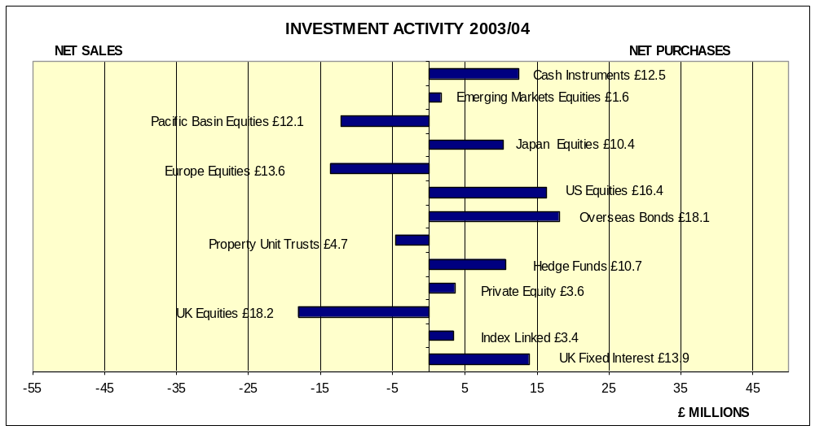

Portfolio Distribution

The distribution of the Pension Fund amongst the principal categories of assets as at 31 March 2004 is shown in the chart below. A comparative chart of the position at 31 March 2003 is also shown. The two further charts show the distribution of overseas investments at 31 March 2004 and 31 March 2003. Changes in the asset weightings, from one year to another, are due to investment activity and market movements.

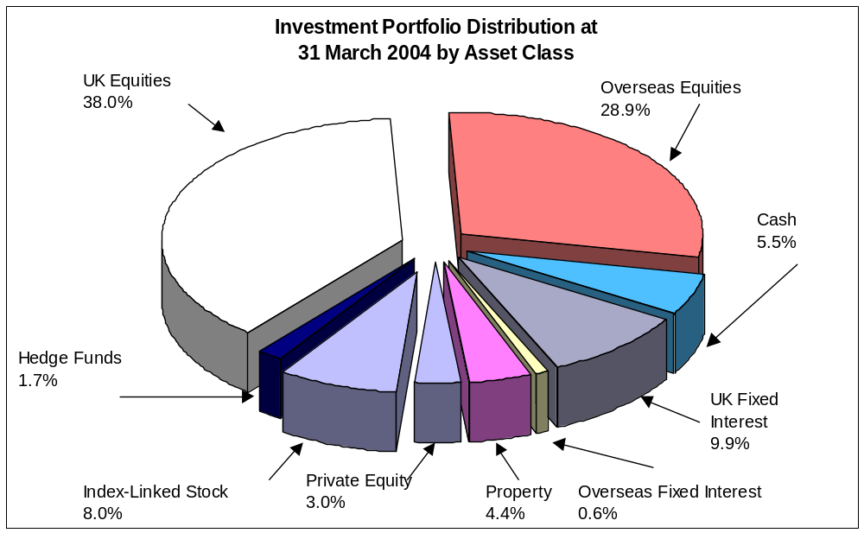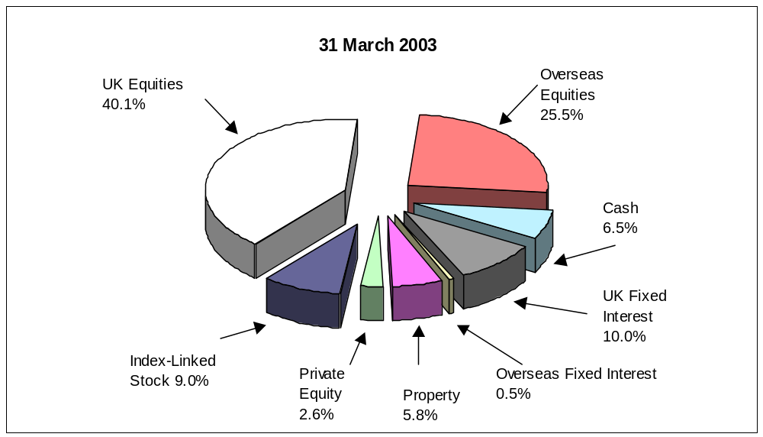

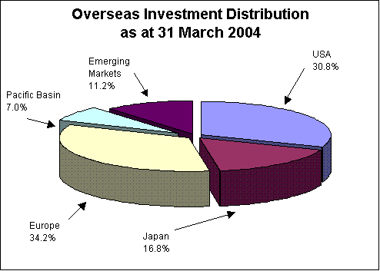

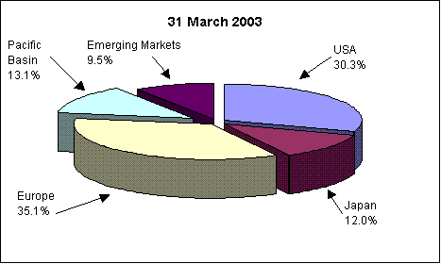

Portfolio Asset Allocation over the Ten Years to March 2004
The total investments of the Pension Fund have grown from £341 million at end of March 1994 to £638 million at end of March 2004 (see chart below).
Over the period the percentage in UK equities decreased from 56.5% to 38.0% whilst bonds
increased from 8.5% to 18.5%.
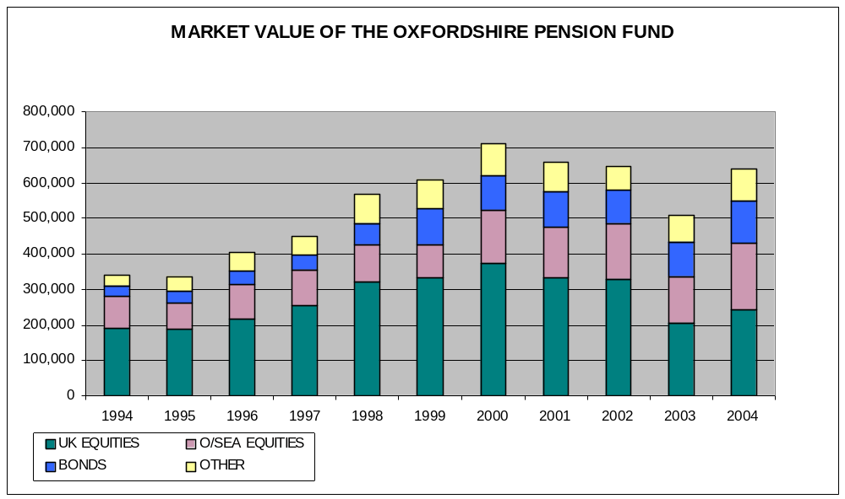

- Investment Performance

- Investment Benchmark and Performance
Following an asset liability study for the Oxfordshire Pension Fund a customised benchmark was agreed for the Fund, which was phased in between 1 July 2002 and 31 March 2003. This benchmark is determined by the overall allocation of the Fund’s assets between geographical regions and asset classes. Within each asset class or region the Fund’s performance is measured against an appropriate index. The main reason for adopting a customised benchmark is to provide a better match of the assets with the liability profile and solvency level of the Fund. Previously the Fund’s benchmark was determined by the median asset allocation of other pension funds – known as the CAPS median.
The Fund’s Benchmark Asset Allocation is shown in the statement of Investment Principals on page 29

The Fund uses Russell Mellon Performance Measurement Service. The Table below provides details of the Fund’s investment performance.
% Returns per annum for the financial year ended 31 March 2004
Actual Returns | 1 year | 3 years | 5 years | 10 years
Oxfordshire Total Fund Return | 23.2 | -2.2 | 3.5 | 6.2
Median Returns and other Comparators
WM Local Authority Median Return | ? | ? | ? | ?
Oxfordshire Benchmark | 24.4 | -0.9* | 4.2* | 6.7*
Retail Price Index | ? | ? | ? | ?
Average Earnings | ? | ? | ? | ?

*The three, five and ten year benchmark figures are a composite of the current customised benchmark and the previously used peer group benchmark.

? Please note – Figures will be inserted as soon as they become available.

FUND ACCOUNT FOR THE YEAR ENDED 31 MARCH 2004
 | Notes | 2004 |  | 2003
 |  | £000 |  | £000
Contributions and Benefits
Contributions Receivable:
Employers |  | 30,772 |  | 25,783
Employees |  | 13,259 |  | 12,118
Total Contributions | 2 | 44,031 |  | 37,901
Transfers from Other Schemes |  | 8,093 |  | 11,414
Other Income – Exceptional Item | 3 | 1600 |  | 587
Income Sub Total |  | 53,724 |  | 49,902
Benefits Payable:
Pensions |  | (26,613) |  | (25,655)
Lump Sums (including retirement and death grants) |  | (4,217) |  | (4,119)
Total Benefits Payable | 4 | (30,830) |  | (29,774)
Payments to and on account of leavers
Refunds of Contributions |  | (435) |  | (441)
Transfers Out (including group and other transfers) |  | (9,528) |  | (11,775)
Administrative expenses borne by the Scheme |  | (632) |  | (871)
Expenditure Sub Total |  | (41,425) |  | (42,861)
Net Additions from dealing with members |  | 12,299 |  | 7,041
Returns on Investments
Investment Income | 5 | 17,127 |  | 16,713
Commission Recapture |  | 21 |  | 32
Change in Market Value of Investments
(realised & unrealised)
Realised Profit/(Losses) |  | 4,948 |  | (33,160)
Unrealised Profit/(Losses) |  | 95,727 |  | (126,480)
Less Investment Management Expenses |  | (1,413) |  | (722)
Net returns on investments |  | 116,410 |  | (143,617)
Net increase in fund during the year |  | 128,709 |  | (136,576)
Opening Net Assets of the Scheme |  | 509,583 |  | 646,159
Closing Net Assets of the Scheme |  | 638,292 |  | 509,583

NET ASSETS AS AT 31 MARCH 2004
 | Notes | 2004 | 2003
 |  | £000 | £000
Investment Assets
Fixed Interest Securities | 6 | 50,574 | 8,309
Equities | 7 | 340,020 | 290,878
Index Linked Securities | 8 | 51,271 | 22,612
Property Unit Trusts |  | 28,105 | 29,442
Pooled Investment Vehicles | 9 | 106,471 | 112,607
Hedge Funds |  | 10,832 | 0
Private Equity | 10 | 19,179 | 13,490
Cash | 11 | 35,332 | 32,993
Total Investments |  | 641,784 | 510,331
Current Assets and Current Liabilities
Debtors | 12 | 9,422 | 6,337
Creditors | 13 | (12,914) | (7,085)
Net current assets and liabilities |  | (3,492) | (748)
Net Assets |  | 638,292 | 509,583

STATEMENT OF ACCOUNTS 2003/04

Note 1 - Accounting Policies

Basis of Preparation

The accounts have been prepared in accordance with the main recommendations of the Financial Reports of Pension Schemes – a Statement of Recommended Practice (the Pensions SORP) which is produced by the Pension Research Accountants Group (PRAG).

Investments

Investments are shown in the accounts at market value, which has been determined as follows:

(a)listed securities are shown by reference to mid-market prices at the close of business on 31 March 2004;
(b)unlisted securities are valued having regard to latest dealings, professional valuations, asset values and other appropriate financial information;
(c)unit trust investments are stated at the mid-point of the latest
prices quoted prior to 31 March 2004;
(d)where appropriate, investments held in foreign currencies have been valued on the relevant basis and translated into sterling at the rate ruling on 31 March 2004.
(e)A change in the basis of the accounting policy in relation to fixed interest stocks was adopted in 2003/04. Market values for 2003/04 have been quoted ‘clean’ (ie the value of interest accruing from the previous interest payment date to the valuation date has been included within the debtor for accrued income, whereas in 2002/03 such interest was included within the market value). This change in the accounting basis has no impact on the surplus or net assets of the fund for either 2002/03 or 2003/04.

Actuarial Valuation

An actuarial valuation of the Fund was carried out as at 31 March 2001.
This valuation showed that the required level of contributions to be paid to the Fund by the County Council for the year ended 31 March 2004 was 231% of members’ contributions. The corresponding rates of contribution that are required from the major participating employers for this period are:

 | %
South Oxfordshire District Council  West Oxfordshire District Council  Cherwell District Council  Oxford City Council  Vale of the White Horse District Council  Oxford Brookes University | 240  257  252  239  213  176

These rates of contribution are the rates which, in addition to the contributions paid by the members, are sufficient to meet:
- 100% of the liabilities arising in respect of the service after the valuation date;
- less an adjustment over a very long period to reflect the amount by which the value of each participating employer’s notional share of the Fund’s assets exceeds 100% of its accrued liabilities, allowing, in the case of members in service, for future pay increases.

Contributions

Contributions represent those amounts received from the various employing authorities in respect of their own contributions and those of their pensionable employees, and have been accounted for on an accrual basis. The employers’ contributions are determined by the Actuary at his triennial valuations of the Fund’s assets and liabilities. Employees’ contributions have been included at rates required by the Local Government Pension Scheme Regulations.

Benefits, Refunds of Contributions and Transfer Values

Benefits payable and refunds of contributions have been brought into the accounts on the basis of valid claims approved during the year. The accounts do not take account of liabilities to pay pensions and other benefits after the scheme year-end. Transfer values are those sums paid to, or received from, other pension schemes and relate to periods of previous pensionable employment. Transfer values have been included in the accounts on the basis of the date when agreements were concluded.
Investment Income

Dividends and interest have been accounted for on the accruals basis. Foreign income has been translated into sterling at the date of the transaction. Income due at the year-end was translated into sterling at the rate ruling at 31 March 2004.

Investment Management and Scheme Administration

A proportion of relevant County Council offices’ salaries, including salary oncosts, have been charged to the Fund on the basis of actual time spent on scheme administration and investment related business. The fees of the Fund’s investment managers have been accounted for on the basis contained within their respective management agreements.

Note 2 – Contributions

 | Employee | Employer
 | Conts | Conts
 | £000 | £000
Oxfordshire County Council | 6,514 | 14,971
Scheduled Bodies | 5,751 | 13,133
Admitted Bodies | 994 | 2,668
Total | 13,259 | 30,772

Note 3 – Other Income – Exceptional Items

Oxfordshire Pension Fund is due to receive an actuarially assessed one off payment of £1,600,000 in settlement of liabilities following a group transfer of staff from Cherwell District Council to Charter Community Housing.

Note 4 – Benefits

 | Pensions | Lump
 | Payable | Sums
 | £000 | £000
Oxfordshire County Council | 13,289 | 2,325
Scheduled Bodies | 12,910 | 1,669
Admitted Bodies | 414 | 223
Total | 26,613 | 4,217

Note 5 – Investment Income

 | 2003/04  £000 | 2002/03  £000
UK Government Stock and Other Fixed Interest  UK Index Linked Bonds  UK Equities and Convertibles  Overseas Equities  Overseas Bonds  Index Linked Overseas Bonds  Property Unit Trusts  Other Unit Trusts  Managed Funds  Cash  Private Equity | 2,311  1,154  7,692  2,366  77  7  1,120  219  619  1,257  305 | 710  254  8,001  1,890  0  0  1,292  735  2,463  1,188  180
 | 17,127 | 16,713

Note 6 -Fixed Interest Securities

 | 2003/04  £000 | 2002/03  £000
UK Public Sector  UK Other  Overseas Public Sector | 17,569  29,181  3,824 | 8,309  0  0
 | 50,574 | 8,309

Note 7 - Equity Investments

 | 2003/04  £000 | 2002/03  £000
UK Listed Equities  UK Stock Index Futures Contracts  Overseas Listed Equities:  USA  Japan  Europe  Pacific Basin | 232,545  1,407  40,962  19,383  38,014  7,709 | 192,756  0  39,328  14,614  44,179  0
 | 340,020 | 290,878

Note 8 – Index Linked Securities

 | 2003/04  £000 | 2002/03  £000
UK Index Linked Bonds  Overseas Index Linked Bonds | 49,377  1,894 | 22,612  0
 | 51,271 | 22,612

Note 9 – Pooled Investment Vehicles

 | 2003/04  £000 | 2002/03  £000
Other Unit Trusts  Managed Funds  Unit Linked Insurance Fund | 0  85,937  20,534 | 29,678  82,929  0
 | 106,471 | 112,607

Note 10 – Private Equity

 | 2003/04  £000 | 2002/03  £000
Listed Investments  Unlisted Investments | 19,064  115 | 13,351  139
 | 19,179 | 13,490

Note 11 – Cash

 | 2003/04  £000 | 2002/03  £000
Sterling Interest Earning Deposits  Cash Backing open stock index futures | 36,739  (1,407) | 32,993  0
 | 35,332 | 32,993

Note 12 – Debtors

 | 2003/04  £000 | 2002/03  £000
Cherwell District Council Housing Transfer  Dividends Accrued  Contributions  Transferred Benefits  Sale of Investments  Early Retirement Hidden Costs  Inland Revenue  Interest on Cash  Pension System Licence Prepayment  Other | 1,600  3,987  1,933  941  524  22  199  24  0  192 | 0  2,732  1,745  1,177  268  131  47  25  24  188
 | 9,422 | 6,337

Note 13 – Creditors

 | 2003/04  £000 | 2002/03  £000
Probation Service Transfer  Transferred Benefits  Inland Revenue  Management Fees  Custodian Fees  Purchase of Investments  Pension Files Scan  Actuary Fees  Legal Fees for Stock Lending Agreement  Other | 8,410  353  435  269  13  3,412  0  16  2  4 | 5,000  1,198  426  222  0  172  49  3  0  15
 | 12,914 | 7,085

Note 14 – Purchases and Sales

 | 2003/04
 | Purchases | Sales
 | £000 | £000
Fixed Interest | 182,354 | 137,234
Index Linked  UK Equities  Overseas Equities | 140,800  549,021  385,874 | 113,090  560,103  400,660
Property Unit Trusts | 42,611 | 47,258
Other Pooled Investment Vehicles | 155,980 | 183,033
Private Equity | 3,793 | 239
Hedge Funds  Cash Instruments | 10,707  450,029 | 0  437,543
 | 1,921,169 | 1,879,160

Note 15 - Assets under External Management

The market value of assets under external fund management amounted to £601 million as at 31 March 2004. The table below gives a breakdown of this sum:

 | 2003/04 |  | 2002/03
 | Market Value  £000 | % | Market Value  £000 | %
Schroders  Deutsche Asset Management  Transition Manager  Alliance Bernstein  Baillie Gifford  Legal & General  UBS | 51  53  48  178,528  127,836  80,844  213,243 | 0.01%  0.01%  0.01%  29.73%  21.28%  13.46%  35.50% | 237,712  246,187 | 49.12%  50.88%
 | 600,603 | 100.00% | 483,899 | 100.00%

Note 16 - Taxation

1. UK Capital Gains and Income Tax - The Fund is an exempt approved fund under the Finance Act 1970 and is not liable to capital gains tax and up until 2 July 1997 was not liable to U.K. income tax on interest and dividends. On 2 July 1997 the Chancellor of the Exchequer in his budget abolished tax credits on advanced corporation tax for pension funds.

2. Value Added Tax - As Oxfordshire County Council is the administering authority for the Fund, VAT Input Tax is recoverable on all Fund activities.

3. US Withholding Tax - Income earned from investments in stocks and securities in the United States is exempt from US Tax.

4. Other Withholding Tax - Double Taxation Relief agreements exist between Britain and certain EC and other European countries whereby a proportion of the tax deducted locally from investment earnings may be reclaimed. The proportion reclaimable and the timescale involved varies from country to country.

TOP TEN HOLDINGS AS AT 31 MARCH 2004

Value of the Fund’s  Top Ten Holdings | £’000 | % of  Fund
Vodafone Group  BP  GlaxoSmithKline  Royal Bank of Scotland  Barclays Bank  HSBC Holdings  Diageo  British American Tobacco  Shell Transport & Trading  Wolseley | 20,187  18,054  16,273  13,634  13,093  11,382  7,486  5,957  4,931  4,391 | 3.16%  2.83%  2.55%  2.14%  2.05%  1.78%  1.17%  0.93%  0.77%  0.69%

AUDIT OF THE OXFORDSHIRE COUNTY COUNCIL PENSION FUND

THE AUDIT CERTIFICATE IS NOT AVAILABLE AT THE MOMENT
BUT WILL BE CIRCULATED TO FUND EMPLOYERS AS SOON AS IT BECOMES AVAILABLE.

CHRIS GRAY
Head of Finance

OXFORDSHIRE COUNTY COUNCIL PENSION FUND
Actuarial Statement

The latest actuarial valuation was made at 31 March 2001 and changes in the contribution rates as a result of that valuation took effect from 1 April 2002.

Security of Accrued Rights
The market value of the Fund’s assets at the valuation date was £658.0 million. In my opinion, the Scheme’s assets existing on the effective date were sufficient to cover 91% of its accrued liabilities as at that date.

Contribution Rates
The rates of contribution set out in the table on page 6 are the rates, which, are payable to the Pension Fund in accordance with Regulation 77 of the Local Government Pension Scheme Regulations 1997.

The contribution rates have been calculated using assets at their market value and adopts rates of investment return based on those market values. The main actuarial assumptions were as follows:
 | Annual Rate
 | Nominal % | Real %
Rate of price inflation | 2.5 | N/A
Future escalation of pensionable pay arising as a result of general economic conditions | 4.3 | 1.75
Allowance for future increases on pensions in payment – (such increases are in line with price inflation) | 2.5* | -
The increase to be expected from time to time in the flow of dividend income from ordinary shares and similar investments | 4.0# | 1.5#
Discount rate for periods
After retirement | 5.90% | 3.40%
Before retirement | 6.75% | 4.25%

*The assumption covers all pensions other than Guaranteed Minimum Pensions (GMPs); post-5 April 1988 GMPs were assumed to increase by 2% per annum; pre-6 April 1988 GMPs have no increases.

# In assessing the ‘credit’ from equity investment used to reduce contribution rates, the rates were assumed to be 4.5% and 2.0% respectively.

P M Stoaling

Fellow of the Faculty of Actuaries
Partner, Watson Wyatt Partners
6 February 2002

SUMMARY OF BENEFITS

Introduction

Membership of the Local Government Pension Scheme (LGPS) secures entitlement to benefits that are determined by statute, contained within the LGPS Regulations. The current regulations were effective from April 1998, and a summary of the main benefit structure follows. For further information please refer to the Scheme Guide.

- Employers’ Discretion

The regulations require each employer within the Oxfordshire Fund to determine their own local policy in specific areas. These policy statements have to be published and kept under review.
The specific areas include how employers will exercise discretionary powers to award additional membership to an active member, agreement to early retirement on request of the member and setting up a shared cost AVC scheme.

- Retirement

The scheme retirement age is 65 for men and women. From age 60 retirement is optional, but the benefit payable will be reduced if the 85 year rule is not satisfied.
Retirement from age 50 is permitted with the employer’s approval.
It is also possible to receive an ill health retirement from any age subject to the appropriate independent medical certification.
From 50, benefits are payable immediately when an employer terminates employment due to redundancy.

Benefits

A retirement benefit, whether payable immediately or deferred, consists of an annual retirement pension and lump sum retirement grant. The minimum period of membership to qualify for retirement benefits is now 3 months. The standard pension calculation is 1/80 of final years’ pensionable pay for each year of membership and the retirement grant is 3/80 of final year’s pensionable pay.
Example
20 years membership, final pay £15,000
Pension.
20 years x 1/80 x £15,000 = £3,750
Retirement Grant
20 years x 3/80 x £15,000 = £11,250

Members can choose at retirement to exchange pension for a larger retirement grant, or to give up retirement grant for a larger annual pension. Both these options are subject to IR maximum limits.

This example does not apply to elected members. Their benefits will be assessed against a career average pay rather than final pay.

Increasing Benefits

During employment members paying additional contributions can use these payments to buy additional membership in the LGPS.
As well as being able to pay additional contributions into the LGPS there is also the group AVC scheme arranged with the Prudential. Additional contributions are invested by the Prudential to enable an annuity to be bought at retirement either from the Prudential or on the open market. At retirement the AVC value may also be used to buy additional LGPS membership.
Members may also make their own arrangements using a stakeholder pension or an FSAVC.

Death

Following a death in service a death grant of up to twice pensionable pay is payable.

Scheme members are recommended to keep ‘expression of wish’ nominations current.

Widows’ and Widowers’ Pension

Widows’ pensions are normally 50% of the scheme member’s pension.
Widowers’ pensions are automatically based on service from 6 April 1988; earlier service may be used subject to the discretion of individual employers.
A widow or widower’s pension will now remain in payment for life.

Early leavers

With less than 3 months membership early leavers have the choice of a refund of their contributions or a transfer to an approved scheme. Entitlement to a deferred benefit exists when membership is at least 3 months. The deferred benefit remains within the fund until retirement or an earlier transfer to an approved scheme.

- Inflation Proofing

Deferred benefits and pensions in payment are increased annually reflecting the rises in the Retail Price Index (RPI)

Ill Health

Independent Medical Advisers qualified in Occupational Health will sign all ill-health certificates. The certification has to declare permanent incapacitation in respect to the current employment and also any other comparable employment.

Early Retirement

Most early retirements incur a cost to the pension fund by way of lost contributions and by increasing the total pension payments. An assessment of these ‘hidden costs’ is made and built into the reporting arrangements prior to the employer agreeing to the early retirement. From April 1999 these hidden costs are recovered from employers and paid to the fund.

- STATEMENT OF INVESTMENT PRINCIPLES

- Overall Responsibility

The County Council is the designated statutory body responsible for administering the Oxfordshire Pension Fund on behalf of the constituent Scheduled and Admitted Bodies. The Council is responsible for setting investment policy, appointing suitable persons to implement that policy and carrying out regular reviews and monitoring of investments.

The review and monitoring of investment performance and fund administration is delegated to the County Council’s Pension Fund Committee. The Head of Finance has delegated powers for investing the Oxfordshire Pension Fund in accordance with the policies determined by the Pension Fund Committee. The Committee is comprised of six County Councillors plus two District Council representatives. A beneficiaries’ representative attends Committee meetings as a non-voting member.

The Committee meets quarterly and is advised by the Head of Finance and the Oxfordshire Pension Fund’s Independent Financial Adviser. The Committee members are not trustees.

- Investment Objectives

The investment objectives are to maximise investment returns over the long term within specified risk tolerances. Investment returns are defined as the overall rates of return (capital growth and income). An asset liability study of the Pension Fund was carried out in 2002. The main purpose of this exercise was to align the Fund’s assets with its liability profile. A specially convened working party of members and officers was set up to consider the most appropriate asset structure for Oxfordshire. Many different scenarios were explored, which set out the risk and reward trade offs. The final asset structure, which was adopted at a special Pension Fund Committee meeting in April 2002, is shown in the SIP.

- Investment Management

Following the asset liability study an extensive review of the Fund’s investment management arrangements was undertaken in the latter half of 2002. The review concluded that a more specialist structure was appropriate going forward. In July 2003, following a detailed tender exercise, four new managers were appointed.
UBS Global Asset Management was appointed to manage a multi asset brief, Alliance Bernstein for global equities, Baillie Gifford for UK equities and Legal and General for UK Bonds.
All the mandates are actively managed against individual benchmarks.
In addition to the four specialist managers a small proportion of the Fund is invested in private equity and hedge funds.

- Asset Allocation

Following the Asset Liability study the Pension Fund Committee agreed the following customised benchmark: -

Asset Class |  | Target Asset Allocation %
UK Equities |  | 40
Overseas Equities |  | 27
Comprising of:
US | 9
Europe | 9
Japan | 3.5
Pacific Basin | 3.5
Emerging Markets | 2
TOTAL EQUITIES |  | 67
UK Bonds |  | 4
Corporate Bonds |  | 8
Index-Linked |  | 10
TOTAL BONDS & INDEX LINKED |  | 22
Property |  | 5
Private Equity |  | 4
Hedge Funds |  | 2
Cash |  | 0
TOTAL OTHER ASSETS |  | 11

Use of derivatives and currency hedging is permitted within pre-agreed limits. Underwriting is permitted, provided that the underlying stock is suitable on investment grounds and complies with existing investment criteria.

- Private Equity Investment

The Fund’s investment in private equity is done through quoted venture capital trusts and a specialist adviser has been appointed to recommend appropriate investments. It has been demonstrated to date that such investment adds value to the fund, providing additional diversification and spread of risk. It is currently Council policy not to invest in unquoted, private venture capital stock. This policy is based on an assessment of the higher risks involved and the difficulties of terminating such investments. Limiting investment to quoted stock would normally preclude local investment except where this might form part of a quoted venture capitalist’s portfolio.

- Hedge Fund Investment

The Pension Fund has approximately 2% invested in hedge funds with the main objectives of achieving further investment diversification and reducing volatility. The investment policy is to invest in a range of funds of hedge funds in order to have an exposure to different investment styles and strategies. UBS Global Asset Management manages the funds.

- Investment Performance Benchmarks, Targets and Ranges

The investment performance of the four managers is measured against their own tailored benchmark, which is constructed from a range of indices, appropriate to the mandate. Similarly the investment performance of private equity and hedge funds is measured against appropriate indices.
Managers are set an objective to outperform their benchmark by a specified percentage over three year rolling periods.
The managers are also instructed to keep within their own individually agreed control ranges. The ranges have been drawn up to ensure the Fund’s investments remain well diversified but also to allow the managers sufficient leeway to actively manage their respective mandates.

- Policy on Risk

Fund Managers are required to implement appropriate risk management measures and to operate in such a way that the possibility of undershooting the performance target is kept within acceptable limits. The mangers report on portfolio risk each quarter.

- Policy on Realisation of Investments

Fund Managers are required to maintain portfolios, which consist of assets that are readily realisable. Any investment within an in-house or pooled fund, which is not readily tradable, requires specific approval.

- Monitoring and Review

The individual manager’s performance, current activity and transactions are presented quarterly to the Pension Fund Committee.

The Statement of Investment Principles will be reviewed annually.

Investment management performance is reviewed annually upon receipt of the annual report prepared by Russell Mellon.

An Annual Forum is held in November or December each year and is open to all Fund employers.

The performance of the Fund’s Additional Voluntary Contributions provider is reviewed annually in a report to the Pension Fund Committee.

Although the investment arrangements are kept under continuous review there is a policy to carry out a strategic review at least once within the life of each County Council.

- Socially Responsible Investment

The Council’s principal concern is to invest in the best financial interests of the Fund’s employing bodies and beneficiaries. Its Fund Managers are given performance objectives accordingly. However, the Council requires its Fund Managers to monitor and assess the social, environmental and ethical considerations, which may impact on the reputation of a particular company when selecting and retaining investments, and to engage with companies on these issues where appropriate. The Council believes that the operation of such a policy will ensure the sustainability of a company’s earnings and hence its merits as an investment; it will also assess the company’s sensitivity to its various stakeholders.

The Fund Managers report at quarterly intervals on the selection, retention and realisation of investments on the Council’s behalf. These Report/Review Meetings provide an opportunity for the Council to influence the Fund Manager’s choice of investments but the Council is careful to preserve the Fund Manager’s autonomy in pursuit of their given performance. The Council will use meetings to identify Fund Managers adherence to the policy and to ask Fund Managers to report regularly on any engagement undertaken.

- Exercise of Rights attached to Investment

The Council takes an interest in the way the companies in which it has made investments manage their affairs. It will always exercise its voting rights to promote and support good corporate governance and socially responsible corporate behaviour.

In practice its Fund Managers are delegated authority to exercise voting rights in respect of the Council’s holdings. They have been instructed to vote in accordance with RREV (Research, Recommendations and Electronic Voting), which is a joint venture between the NAPF (National Association of Pension Funds) and ISS (Institutional Shareholder Services). However, in exceptional circumstances managers may vote differently to RREV, if in their judgement this would be in the best interests of the fund. Where managers take a contrary view to the RREV they must obtain permission from officers to vote differently.

Fund Managers are required to report quarterly on action taken. The Council, through its Fund Managers, may act with other pension funds to influence corporate behaviour and, apart from the exercise of voting rights in concert with others, may make direct representation to the boards of companies through its Fund Managers in concert with others, on issues of social responsibility.

- Custody

The Pension Fund appointed an independent global custodian, ABN AMRO Mellon Global Securities Services, on 1 April 2003. The custodian holds all the Fund’s assets except a working cash balance, which is held by the County Council and invested in the wholesale money market.

- Administration
On behalf of the County Council, the Head of Finance is required to exercise continual monitoring of the managers’ investment related actions and administration.

This includes:-

maintaining the investment ledger and suitable accounting procedures for Fund assets;

preparing and submitting statistics quarterly for performance measurement;

preparing a quarterly report to the Pension Fund Committee;

preparing the audited annual report and accounts for employing bodies – before end of October each year (statutory date);

preparing a summarised report to members – annually by end of December;

maintaining an up to date record of fund cash balances to ensure surplus cash is invested promptly or that resources are available to meet the benefit outflow as it arises.

- Compliance with the ten investment principles contained in the CIPFA document “Principles for Investment Decision Making in the Local Government Pension Scheme in the UK.”

The Oxfordshire Pension Fund complies with the ten principles, with the exception of the following issues:-

Activism. This involves a pension fund’s managers being proactive in their dealings with company managements. A formal report will be produced for the Pension Fund Committee later in 2004, which will consider the policies of its managers in relation to their engagement with companies. It will then be decided whether the Pension Fund as a whole can be considered to be pursuing an activist policy.

Monitoring Transaction Costs. The principles recommend the need to understand all transaction costs and the desirability of monitoring these. Some progress has been made on monitoring these costs and now all four managers report quarterly detailed information, to the Pension Fund Committee, on their trading volumes and commissions. However, the monitoring of the less transparent costs, such as the market impact of trading, also needs to be done to fully comply with this principle. The Independent Financial Advisor is discussing this aspect with the four managers and he will report to the Pension Fund Committee on this later in 2004.

.

COMMUNICATION

The Pension Fund has endeavoured to improve its communications with all employing bodies, contributors and pensioners. The following initiatives are currently in place: -

- Annual Report and Accounts - This is circulated to all Oxfordshire County Council Chief Officers, all employing bodies and copies are available for public inspection in the main Oxfordshire public libraries.

- Summary of Report and Accounts Leaflet – This is circulated to all contributors and pensioners in the Oxfordshire Fund.

- Annual Pension Fund Forum – This is held each autumn and all employing bodies are invited to send representatives. The purpose of the forum is to keep employing bodies informed of topical issues and events that have occurred in the last year and also to give them the opportunity of raising any questions in relation to the Pension Fund. Representatives are written to prior to the forum and invited to submit any topics for discussion.

- Pensions User Group – This is a quarterly held meeting for all employing bodies within the Oxfordshire Fund. The purpose of the group is to inform, consult and discuss pension matters such as changes in legislation, the results of the actuarial valuation and other policy changes.

- Employee Guide to LGPS – This is a booklet, which summarises the benefits of the Scheme. It is available for all employees and updated to reflect any changes as and when necessary.

- Short Guide to the LGPS – a reduced version of the scheme guide, with main points, given to all employees on starting employment.

- Reports by Beneficiaries Observer – The beneficiaries’ observer attends all Pension Fund Committee meetings as an observer. He has no voting rights but is allowed to speak with the permission of the Chairperson. A written report of each meeting is circulated to all employing bodies for their staff.

- Pension Bulletins –Bulletins are distributed to all scheme members within the fund. They are issued when there major changes to the LGPS. This is to ensure that Oxfordshire County Council complies with the Disclosure of Information Regulations.

- Intranet – Pensions and Investment information is available on the intranet, including copies of the Pension Fund Committee reports & minutes.

- Talking Pensions – Monthly informal newssheet for all employers in the Oxfordshire Fund distributed to all Human Resource and Payroll contacts.

USEFUL CONTACTS AND ADDRESSES

BENEFIT ADMINISTRATION

Pensions Services
Resources
Oxfordshire County Council
County Hall
Oxford OX1 1TH

Telephone: 01865 815209
Email: pension.services@oxfordshire.gov.uk

ACCOUNTS AND INVESTMENTS

Tony Wheeler
Pension Fund Investment Manager
Financial Services
Oxfordshire County Council
County Hall
Oxford OX1 1TH

Telephone 01865 815287

email:tony.wheeler@oxfordshire.gov.uk

BENEFICIARIES OBSERVER

Malcolm Leeding
c/o Pensions Services
Resources
County Hall
Oxford OX1 1TH
Telephone 01865 815327

SPECIFIED PERSON FOR INTERNAL
DISPUTE RESOLUTION PROCEDURE
Second stage disputes to be sent to:-

Sally Fox
Pensions Services Manager
Resources
Oxfordshire County Council
County Hall
Oxford
OX1 1TH

The Occupational Pensions Regulatory Authority (OPRA)
Invicta House
Trafalgar Place
Brighton
East Sussex
BN1 4DW 01273 627600

The Registrar of Occupational and Personal Pension Schemes
PO Box 1NN
Newcastle upon Tyne
NE99 1NN

The Occupational Pensions Advisory Service (OPAS)
11 Belgrave Road
London
SW1V 1RB 0845 6012923

Pensions Ombudsman
11 Belgrave Road
London
SW1V 1RB 020 7834 9144

